Test File
31 March 2025
15:30
Class: | Test class | Files:
Topic: | Test topic
Website: | Test website

Cues | Notes
- Item 1 | Test note 1
- Item 2 | Test note 2
- Item 3 with more details | Test note 3
- Test numbered list | - A  - B  - C  - D  - E  - F  - G  - H  - I  - J  - K  - L  - M  - N  - O  - P  - Q  - R  - S  - T  - U  - V  - W  - X  - Y  - Z

- A
- B
- C
- D
- E
- F
- G
- H
- I
- J
- K
- L
- M
- N
- O
- P
- Q
- R
- S
- T
- U
- V
- W
- X
- Y
- Z

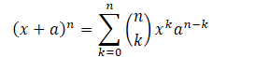
Binomial Theorem

Summary
  - Test summary

Study Questions
  - Test question

